R.V. COLLEGE OF ENGINEERING,

BANGALORE-560059

(Autonomous Institution Affiliated to VTU, Belgaum)



**SELF STUDY REPORT ON**

**“Automated Electric Meter Billing”**

*Submitted by*

**Pratyush Singh 1RV16CS104**

**Hemanth Rao K N 1RV17CS410**

**Raghavendra 1RV17CS424**

**Ujwalakavya J 1RV17CS435**

*Under the guidance of*

**Name of the teachers with proper designation**

*Submitted to*

**COMPUTER SCIENCE AND ENGINEERING DEPARTMENT**

**R.V.College of Engineering, Bangalore-59**

**R.V. COLLEGE OF ENGINEERING, BANGALORE - 560059**

**(Autonomous Institution Affiliated to VTU, Belgaum)**

**DEPARTMENT OF COMPUTER SCIENCE AND ENGINEERING**



**CERTIFICATE**

Certified that the Self Study work titled **“Automated Electric Meter Billing”** is carried out by, Pratyush Singh – 1RV16CS104, Hemanth Rao K N – 1RV17CS410, Raghavendra – 1RV17CS424, Ujwalakavya J – 1RV17CS435, who are bonafide students of R.V College of Engineering, Bangalore, in partial fulfillment for the academic requirement of **Fifth semester** ​Bachelor of Engineering in Computer Science and Engineering of the Visvesvaraya Technological University, Belagavi during the year 2017-2018. It is certified that all corrections/suggestions indicated for the internal Assessment have been incorporated in the report. The Self Study report has been approved as it satisfies the academic requirements in respect of Self Study work prescribed by the institution for the said degree.

**Respective sections Teachers Names with designation**

TABLE OF CONTENTS

**Sl. No. Content Page no.**

**1. Introduction 4**

**2 . Literature Survey 5**

**3. Application of Engineering Principles 6**

**4. Selection of appropriate skills, techniques 6**

**5. Design Process 7**

**6. Correlation wih Self-Study subjects 8**

**7. References 9**

**INTRODUCTION**

Automated meter reading systems are a invaluable technological

advancement that can lead to a better standard of living, owing to the fact

that metering has become a part and parcel of our mundane lives.

It solves many issues of the traditional meter reading system like need for

human resources, lack of efficiency and accuracy in meter reading, delayed

work, unavailability of customer during metering visit by employee, etc.

Moreover it is more economical and helps to save energy in a more efficient

and effective way. Furthermore it has a very notable advantage of having

the ability to predict the energy demands of the future, starting from every

household to the entire planet.

Automated meter reading systems have been implemented using many different

technologies like GSM, ZigBee, PLC, D-SCADA, WiMAX and Hybrid

Technologies that comprises of a mixture of the above.

**LITERATURE SURVEY**

This article reviews the technical features of automatic meter read (AMR) systems for residential small commercial natural gas meters, including a look at the new static gas meters. AMR systems are today quite widespread for electrical residential meters, but are still in an experimental (pilot projects) stage for other applications in utility meters, such as natural gas residential and small commercial meters.AMR systems allow the recording of gas consumption in an efficient way with some important advantages for the overall gas system, both for the provider and for the user. The main AMR benefits for the customer are:

* Convenience. Meter readers are eliminated;

* Efficiency. The AMR system eliminates estimated meter reads; and

* Accuracy. The electronic unit of AMR, equipped with a reliable encoder technology, is more accurate than manual (or semi-manual) meter reads, thereby eliminating human errors.

New enablers such as automated meter reading (AMR) can be applied to capture and leverage information to help utilities proactively achieve these competitive objectives. Advanced capabilities such as predictive analysis, simulation tools, contingency analysis and network monitoring can go far in giving utilities the power to be successful. Automated meter reading systems are an attractive technology for cutting costs while increasing speed and control of metering activities. When organizations, such as utilities, military installations, large industrial parks and school districts consider automated meter reading technology, they discover most available systems carry high initial capital costs. Organizations that purchase systems without first evaluating the full costs and benefits often find they are locked into a technology that accomplishes less than they need. Each level of that process took time and was error prone. The introduction of handheld devices saved time and reduced errors. Drive-by metering further improved the data collection process. This report on Automated Meter Reading Technologies explores this emerging industry in depth, focusing on the manufacturers and suppliers of AMR technology and equipment, and current trends in the AMR industry. The report also explores the market statistics pertaining to water utilities, available technology, current business requirements, and much more. The report takes a look at the newly gained interest of venture capitalists in automated meter reading technology markets and how it is affecting the industry overall. Read on to find out how this new technology is changing the today utility landscape.

Now a days wireless communication has become ubiquitous around the world and its application for gauging consumption of utilities by customers is rapidly gaining pace, not only in the developed world but also in the developing countries.

**APPLICATION OF ENGINEERING PRINCIPLES**

Smart automated process instead of manual work. Accurate information from the network load to optimize maintenance and investments. Customize rates and billing investments. Streamlined high bill investments. Detection of tampering of Meters. Better company credibility.

**SELECTION OF APPROPRIATE SKILLS, TECHNIQUES**

Automated electric bill generating project consists of n ZigBee modem connected to a microcontroller of 8051 family. The embedded micro controller is interfaced with the ZigBee module. This setup is fitted in home. The energy meter is attached to the micro controller. This controller reads the data from the meter output and transfers that data to ZigBee Module through the serial port. The embedded micro controller has the knowledge of sending message to the system through the ZigBee module. Another system is placed in EB office, which is the authority office. When they send “unit request” to the microcontroller which is placed in home, then the unit value is sent to the EB office PC through ZigBee module. According to the readings, the authority officer will send the information about the bill to the customer.

**DESIGN PROCESS**

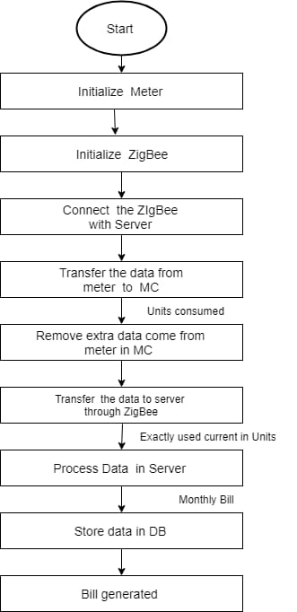

**CORRELATION WITH SELF-STUDY SUBJECTS**

The concepts related to the various semester subjects are given below:

1. DBMS – Database is used to store different types of customer data and their monthly bills.
2. ANN – we are using electric meter to measure the current used. Ardino board will transfer data from meter to ZigBee. ZigBee will transfer the data to server which will be stored in Database for further use to calculate bill.

**REFERENCES**

1. ***Khanh tuan le, designing a ZigBee-ready ieee 802.15.4-compliant radio transceiver. Chipcon, pp.111,2004***
2. ***Shahin farahani, “ZigBee wireless networks and transceivers.***
3. ***W3school tutorials for mysql.***
4. ***Tutorials point for MongoDB.***